**Health Fund Rebates**

If you have private health insurance you may be eligible for a rebate on your sessions. Check with staff for more information as not all health funds are included.

**Session Times**

talk to staff about session times for other program. additional fees will apply.

**BOOKINGS ARE ESSENTIAL**

Staff at Live Well will take you through the equipment at your initial visit and set you up on your program. There is always someone available to help, but just like attendance to the DRU maintenance group, you need to be able to exercise independently. One- on- one personal training can be arranged at an extra cost.

Changes to your program and fitness testing can be done but will incur a charge.

**Where is Live Well?**

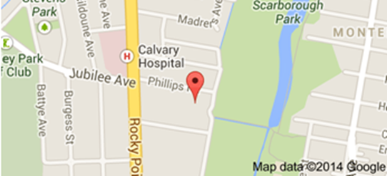

3/22 Phillip Street, Kogarah.

Ph: 9587 4100

Take Production Ave off Rocky Point Rd and loop around to the studio at the Scarborough Park end of the street

For more information call Live Well on 9587 4100 or ask the staff at the Day Rehabilitation Unit Calvary Hospital, Kogarah**

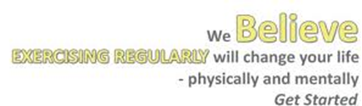

**Want to continue your fitness training but don’t like busy gyms?**

Why not try **Live Well Fitness** at 3/22 Phillip Street, Kogarah.

**Ph: 9587 4100**

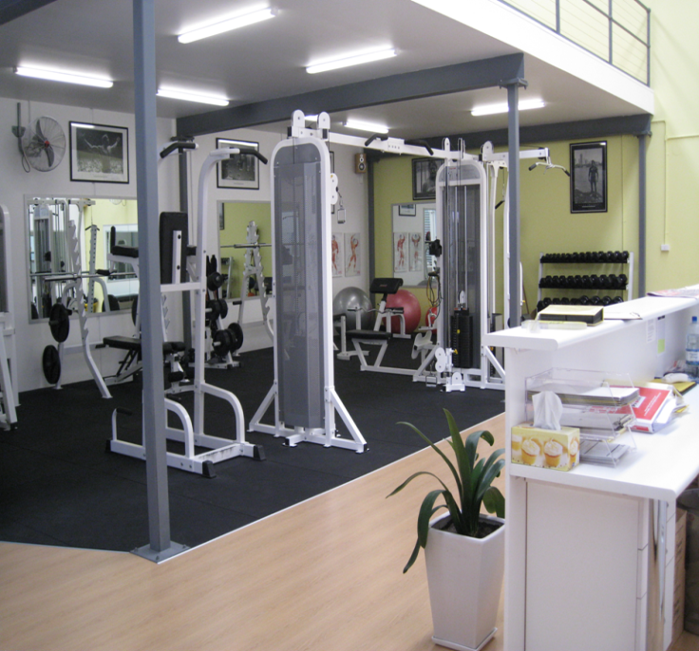

**Calvary Day Rehabilitation Unit & Live Well**

**The aim** of the alliance between Calvary and Live Well is to encourage clients to move from the hospital setting to the community for ongoing health/lifestyle management in a setting safe & suitable for elderly clientel.

A special rate has been developed for clients wishing to continue to improve their health, but who don’t like being locked into contracts and want a relaxed friendly workout atmosphere.

This special offer is only available to clients who have attended the Calvary Day Rehabilitation Unit.

Access to the facility at the reduced rate is only between the hours of 9am-5pm.

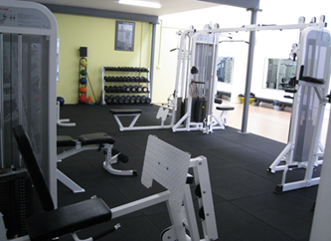

**What does Live Well offer?**

Only 300m from Calvary, this fitness studio offers a wide range of equipment in a friendly, relaxed environment.

The fully equipped gymnasium includes resistance machines, exercise bikes, treadmills and free weights.

They also run classes such as Yoga and Boxercise, as well as one on one personal training at extra cost.

Clients of Calvary are always able to return to the DRU program should they need further assessment and treatment.

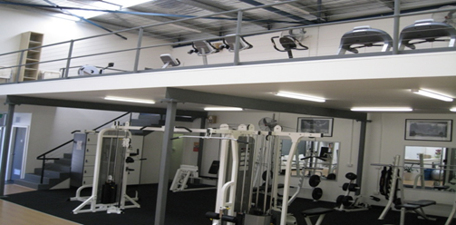

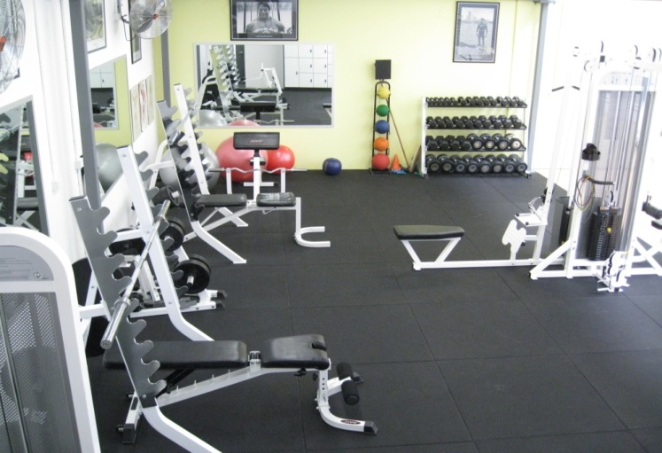

### Fees: Parkinson’s exercise class

Tuesday, Wednesday & Friday 11am -12pm

$15 per session or

10 sessions for $100

Cash, credit card and direct debit payment facilities are available.

Program updates and fitness testing

Full gym access costs vary

### What to Bring

* + Wear comfortable day attire suitable for exercise, **your own towel** and **water bottle**
  + Comfortable footwear